Grandmaster San Gee Tam left his body on December 25, 2020

It is with a huge sense of sadness that we say goodbye to our beloved teacher, friend and mentor, the head of our tai chi “family” and the founder of the Golden Flower Tai Chi School. We are very grateful and privileged for all the teachings, friendship, insights and laughter. Though we will miss his physical presence, his spirit will stay forever.

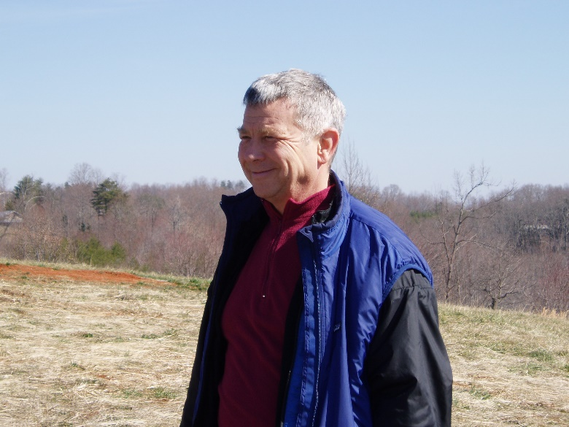
Our hearts go out to his wife, Master Annukka Holland, his family and to the whole Golden Flower School community.

Grandmaster San Gee Tam devoted boundless love and energy to our School, and many friends are ﬁlled with the richness of his teaching. For the hundreds that have absorbed his teaching, it is like a bright light that shines within us. His physical presence will be greatly missed by so many people whose lives he touched, and all grieve the loss of the teacher and friend that we loved and will continue to love. There is a feeling that his spirit will remain as strong as ever, unrelenting, encouraging growth, adaptation and enjoyment of being.

Born James Holland in Winston Salem in 1946, he was aware of being ‘conscious’ from a young age and initially channeled his enthusiasm into music - speciﬁcally jazz music on the ﬂute. He went to Berklee school of music in Boston and became a professional jazz musician. In 1969 he joined in the Navy and served as an air traffic controller in Vietnam during the War.

His path of mastery opened up through the deep connections he made with Master teachers.
He was a disciple of Kundalini Master Muktananda, and for four years, he was an instructor for the original Arica School of Scientific Mysticism with Master Oscar Ichazo. Later he went to Pune to continue his work under Osho, who initiated him into the mysterious reality of subtle energy awareness and meditation. From Osho he received the name Swami Anand Sangeetam (“Anand Sangeetam” means “Celestial Music”).

After India, he moved to London to further his study of Tai Chi as a private student of Grandmaster Chu King Hung, oﬃcial representative and lineage holder of the of the Original Yang Style, by authority of Master Yang Shou Cheung, eldest son of Yang Cheng Fu. Grandmaster San Gee Tam was Chief Instructor-At-Large in the International Tai Chi Chuan Association (ITCCA) and founder of ITCCA in Brussels. He was instrumental in popularizing Tai Chi in Belgium. He studied for 15 years with Grandmaster Chu and was fortunate to receive the “seed teaching’’ of the complete Small Circle. Whilst in London, Grandmaster San Gee Tam combined his study of Tai Chi with the process of continual self-improvement that was the est training (Werner Erhard).

During his time in Europe, Grandmaster San Gee Tam founded Creative Interactions, an organization that presented a wide range of courses in the area of self-development and essential personal education. This organization was integrated into the Golden Flower School, and over the decades, he trained many people in self-cultivation, energy reﬁnement, natural healing, bodywork, communication and meditation.

Following the time with Grandmaster Chu, Grandmaster San Gee Tam continued his work with Master teachers by commencing a 25-year period of private Tai Chi study with Grandmaster Dong Zeng Chen, grandson of the famous Tung (Dong) Ying Chieh. In the early ’90s, after returning to the USA, Grandmaster San Gee Tam joined the School of Daoist Master Ni-Hua Ching. His study of the Integral Way with Master Ni was a source of lifelong inspiration, and from Master Ni he received the name San Gee Tam which means “he whose life/presence beneﬁts all people.”

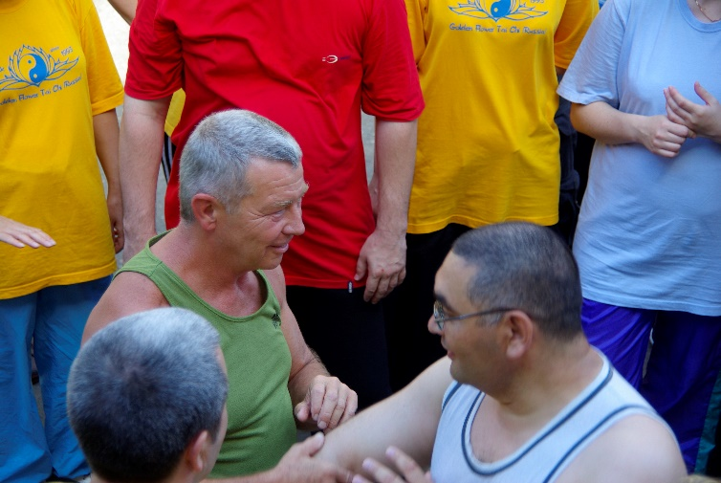
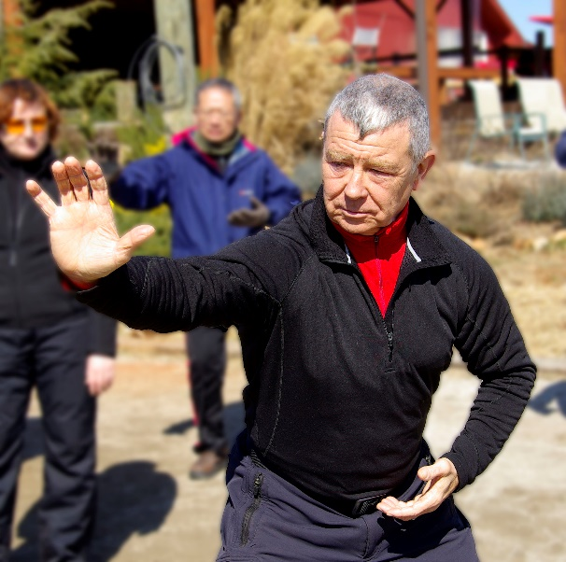
Grandmaster San Gee Tam’s areas of accomplishments are many and cover a wide range of life from ﬁlm-making, windsurﬁng and biking to Spartan racing and horsemanship. However, his greatest work was the establishment of the Golden Flower Tai Chi School. It was within the environment of this school that he was able to integrate the Master level teachings that he was so fortunate to have received — and to begin passing that on. Through the School, he had a deep personal connection and life altering impact on countless people, friends, seekers and Tai Chi practitioners. The school developed as a unique combination of Tai Chi, self-development and a “community that works together harmoniously.” The School thrives in the UK, Netherlands, Belgium, USA and Russia, with close to a thousand students worldwide.

Over the years, hundreds of people have completed the Golden Flower Instructor Test. Grandmaster San Gee Tam always insisted upon very high standards, so passing the test to become a Golden Flower Instructor has always been a huge achievement. The School thrives through regular, weeklong training events and retreats held several times a year in Europe and America. The Trainees, Senior Students and Instructors who attend continue to broaden and deepen their learning from his endless knowledge, understanding and embodiment of Tai Chi and of the principles of life. He has encouraged us all into a continual process of reﬁnement. Private sessions with Grandmaster San Gee Tam were powerful, invaluable experiences.

The growth of the School blossomed in the attainment of a lifelong wish to establish a permanent Retreat Centre. In 2006, the school established its heart at The Heavenly Way Retreat, surrounded by nature and horses in the foothills of the Smoky Mountains. This is the heart of the school; it is our playground for intense training, experienced by many as a tangible ﬁeld of consciousness and happy chi.

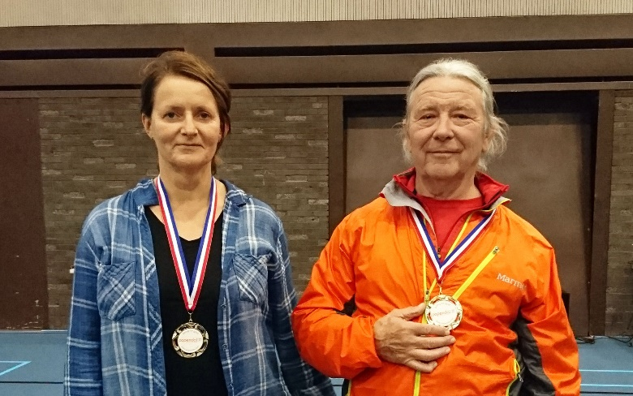
In 2019 Grandmaster San Gee Tam announced that his wife and long-serving student had reached the level of Golden Flower Tai Chi Master. Having been able to train his student to master level, former Master San Gee Tam became a Grandmaster. Now, Master Annukka becomes the new Master of the School. We are immensely grateful to Master Annukka for the 24/7 training that she took on. We appreciate her unique approach and look forward to learning in a new and diﬀerent way from her.

Grandmaster San Gee Tam focused his intention and energy into the School, and in a relatively short time, he established a detailed curriculum for Golden Flower students as well as instructors and expanded the ﬁeld of study to include Bagua, Hsing-I and weapons training. He brought it all to the school in a comprehensive and multi-level way.

The methods at the centre of the Golden Flower system incorporated teachings from all the masters that Grandmaster San Gee Tam had learned from and were embodied in the forms he adapted from the Yang family - the Golden Flower Qigong Form, Standard Form, Fast Form and Long Form - as well as all their associated exercises, Qigong sets and standing postures. This serves and will continue to serve countless students worldwide, of all ages and all levels.

Grandmaster San Gee Tam attained the ability to demonstrate the martial applications of Tai Chi with eﬀortlessness. He also was able to apply his insight to students in a way that made them able to reflect on their own blocking and wasting patterns, whether they be physical, psychological or spiritual.

As the founder of the Golden Flower School, Grandmaster San Gee Tam was a natural leader who was sometimes confronting but always loving and in service to the ongoing process. We feel sure that his spirit will continue to provide leadership for us as we continue the work that he began. His work and legacy will be continued by Master Annukka Holland, the body of dedicated instructors and all members of the Golden Flower community.

This communication from the International Golden Flower Tai Chi School and is approved by Master Annukka Holland, January 2021.

